

Mind BLMK

Employment Application Form

Post applied for:
Where did you see this post advertised? |  |  |  |  |  |  |  |  |  |  | (please specify which website or publication)
Please complete all pages of this form as well as the Equal Opportunities and Disability Monitoring Form.
PERSONAL
First / other names:
Surname / family name:
Address:
Postcode:
Home tel. no: |  |  |  |  |  |  |  |  |  |  |  |  | Work tel. no:  (Contact during office hours will be with discretion)
Mobile no:
Email address:
EDUCATION, QUALIFICATIONS AND TRAINING
(Only include qualifications and training that are relevant or required for the post)
Education, qualifications and training |  |  |  |  |  |  |  |  |  |  |  |  |  |  |  |  |  |  |  |  | Dates
EMPLOYMENT HISTORY
Current or most recent employment:
Employer: |  |  |  |  |  |  |  |  |  |  |  |  | Job title:
 |  |  |  |  |  |  |  |  |  |  |  |  | Salary:
From:  (month and year) |  |  |  |  |  |  |  |  |  |  |  |  | To:  (month and year)
Summary of duties:
Reason for leaving:
Previous employment:
Dates: | Job title with brief description of duties |  |  |  |  |  |  |  |  |  |  |  |  |  |  |  | Employer:
REFERENCES
(Please give details of at least two referees who are able to comment on your work ability. One referee should be your current or most recent employer. References must cover the last three years of employment)
Referee 1: |  |  |  |  |  |  |  |  |  |  |  | Referee 2:
Name: |  |  |  |  |  |  |  |  |  |  |  | Name:
Address: |  |  |  |  |  |  |  |  |  |  |  | Address:
Email: |  |  |  |  |  |  |  |  |  |  |  | Email:
Tel no: |  |  |  |  |  |  |  |  |  |  |  | Tel no:
Relationship of referee to you: |  |  |  |  |  |  |  |  |  |  |  | Relationship of referee to you:
May we contact this referee before interview? |  |  |  |  |  |  |  |  |  |  |  | May we contact this referee before interview?
OTHER
DBS clearance and criminal convictions
Working in certain positions for Mind BLMK is subject to satisfactory Disclosure and Barring Service (DBS) clearance – this check was previously called a CRB clearance.
Mind BLMK will process an enhanced DBS check for you to include regulated activities
with adults as well as children. If you object to these checks being carried out, please email hr@mind-blmk.org.uk or tell the evidence-checker, in which case your application will be reviewed. Because of the nature of the work of staff in the organisation, the posts are exempt under the Rehabilitation of Offenders Act 1974 and you are required to reveal all convictions, including those that are spent.
Do you have any criminal convictions you need to disclose?
If you answered “yes” to the above, please declare convictions sealed in an envelope marked “Chief Executive”, Private and Confidential, Addressee only”.
Eligibility
If you are not a member of the European Economic Area, are you entitled to work in the UK?
Please provide a copy of your passport and other necessary documentation to support your right to work in the UK.
Availability
If you were appointed, when would you be able to take up the post?
Accessibility
Please tell us if there is anything we need to know in order to provide you with a fair interview, eg interpreter, wheelchair access.
ADDITIONAL INFORMATION
- Appointments are subject to acceptable references.
SUBMITTING APPLICATIONS
Applications submitted electronically:
To return your application electronically, please email this form to: hr@mind-blmk.org.uk
Applications completed by hand:
Please return this form as well as the completed Equal Opportunities and Disability Monitoring Form to marked “Private and Confidential” to:

Sonnet Church
Mind BLMK
The Rufus Centre
Steppingley Road
Flitwick
MK45 1AH
DECLARATION
I confirm that the information on this form and in any attachments in respect of this application is correct. I understand that false or misleading information or failure to disclose a conviction as defined above, may lead to dismissal. I also understand that the information may be entered on a computer and, under the terms of the Data Protection Act 1998, will be treated in a secure and confidential manner.

Signed: Date:

Please note: By submitting applications electronically you confirm that information supplied is correct. You will be asked to sign and date a printed copy of your application if selected for interview.
Data Protection Act 1998
Information provided by you in this application process will be kept for the purposes of monitoring and will be copied for use during the recruitment process. Once the recruitment process is completed, the data will be stored for a maximum of 6 months and then destroyed. If you are the successful candidate, relevant information will be taken from application papers and used as part of your personnel record.
EXPERIENCE, SKILLS AND KNOWLEDGE
(Please explain and demonstrate how you meet the selection criteria in the Person Specification)
(Please continue on a separate sheet if necessary)
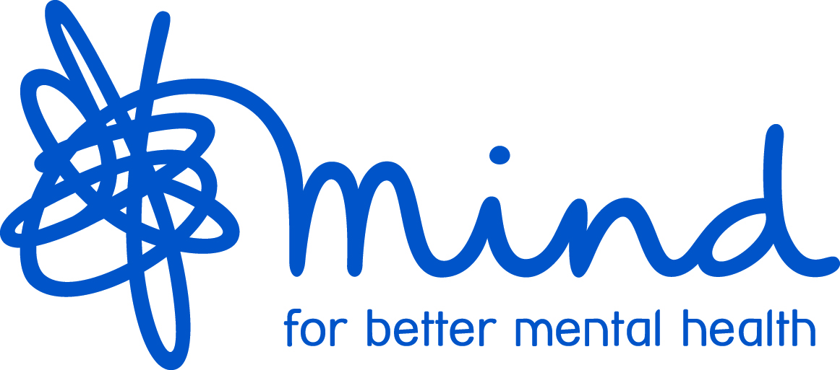

Mind BLMK

Equal Opportunities and Disability Monitoring

We aim to provide equal opportunities and fair treatment for everyone. We would like you to complete this form in order to help us understand who we are reaching and to better serve the community. All details will be treated as confidential and are held in accordance with the Data Protection Act 1998.

Name:
Age group: | Gender: |  | Sexual orientation: | Religion/Faith:
17 or under   18-29   30-39   40-49   50-59   60-69   70 and over   Prefer not to say  | Male   Female   The gender ticked above is different from the sex assigned to me  at birth   Prefer not to say  |  | Bisexual   Gay man   Lesbian   Heterosexual   Other   Please specify:  Prefer not to say  | No religion/faith   Christian (any  denomination)   Buddhist   Hindu   Sikh   Muslim   Jewish   Other   Please specify:  Prefer not to say 
Disability: |  | Ethnicity:
Are your day-to-day activities limited because of a health problem or disability which has lasted or  is expected to last for at least  12 months?  No   Yes, limited a lot   Yes, limited a little   Prefer not to say   If yes, please specify briefly: |  | White English / Welsh / Scottish /Northern Irish /British   White Irish   White Gypsy or Irish Traveller   *Any other white background   Mixed White and Black Caribbean   Mixed White and Black African   Mixed White and Asian   *Any other mixed background   Black or British African   Black or British Caribbean   *Any other black background   Asian or British Indian   Asian or British Pakistani   Asian or British Bangladeshi   Asian or British Chinese   *Any other Asian background   *Please specify:  Prefer not to say 

Thank you for completing this form

