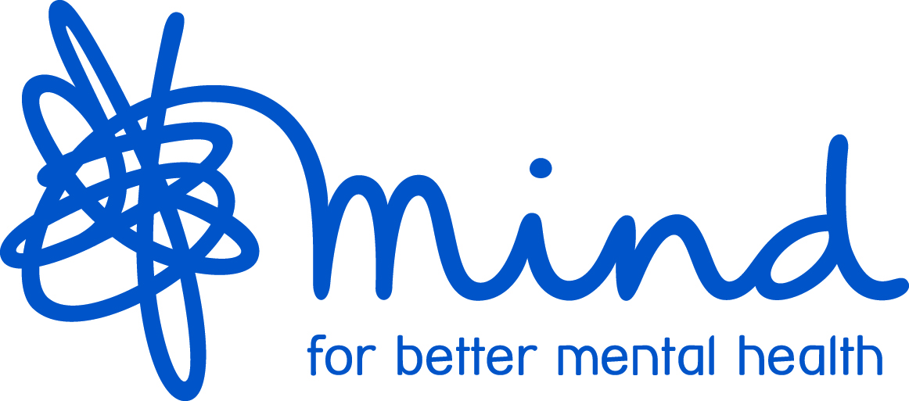

Mind BLMK - Volunteer Opportunity

Opportunity title: | Trainee Volunteer Counsellor with recognised qualifications.
Closedown date for applications: | Ongoing
Duration of volunteer placement: | Ongoing
Staff support: | Counselling Coordinator, Service Manager and Counselling Lead
Based at: | Samuel Whitbread School Bedfordshire  and Mind BLMK, Margaret Powell House, Midsummer Boulevard Central Milton Keynes MK9 3BN
Working days and hours: | Commit to a minimum of 3 counselling hours a week.  For a period of 2 years.
Summary of duties and objective: | To provide counselling to students referred through a specific referral process and assessed as suitable for therapy. To work in a brief therapy model of 6 sessions (BT training will be offered to successful applicants if required). All approaches welcome.
Expenses covered: | Contribution to travel costs.
Skills and experience needed: | Applications are welcome from students who are undertaking training in counselling and therapeutic practice through a provider recognised by Mind BLMK.  (See list of Mind BLMK recognised Training providers and qualifications.)
Other requirements/expectations: | - A recognised professional counselling qualification.  - To meet the specific BACP Competency Framework for working with Children and Young People.  - To have a full understanding and working knowledge of the PREVENT strategy specifically for a school environment.  - Current Safeguarding for Children and Young People training.  - All counsellors are expected to work within the ethos of the organisation in the promotion of individual recovery and social inclusion and in line with the BACP ethical framework and the organisational policies and procedures of Mind BLMK.  - To attend Quarterly team meetings with the option of attending training on the same day.  - Must be able to make full use of clinical supervision both one to one and group (provided by Mind BLMK).  - To maintain adequate records of clinical work.  - Ensure that dignity, equality, diversity are upheld with clients and colleagues.  - Helpful to have experience of working in mental health services, other healthcare settings and/or significant life experience.  - Must be able to work as a team member.  - Application form must be completed in full.  - Attend interview(s) for selection.  - Successfully complete a 6 month trial period.  - Satisfactory DBS clearance.  - Two satisfactory references.  - Successfully complete Mind BLMK Induction Training.

Mind BLMK

Volunteer Application Form

Private and Confidential

Opportunity interested in: Trainee Volunteer Counsellor with recognised qualifications
Please complete all pages of this form as well as the Equal Opportunities and Disability Monitoring Form.
PERSONAL INFORMATION
Name:
Address:
Tel no:
Mobile no:
Email will be used as the main means of communication and by supplying an email address, it will be accepted as agreement by you to receive communication electronically:
Email address:

EMERGENCY CONTACT DETAILS
Name:
Relationship to you:
Contact no:
Health needs:

REFERENCES (Please provide the name and contact details of two people who could act as referees. Neither should be related to you and one should be a previous employer or other professional person if possible.)
Email will be used as the main means of communication and if supplying an email address for a referee, it will be used to request a reference electronically:
Referee 1: |  | Referee 2:
Name:  Address:  Post code:  Email: |  | Name:  Address:  Post code:  Email:
Relationship of referee to you: |  | Relationship of referee to you:
EDUCATION, QUALIFICATIONS AND TRAINING
(Only include qualifications and training that are relevant or required for the post)
Education, qualifications and training |  |  |  | Dates

SKILLS AND EXPERIENCE (To support your application, please use this space to tell us how you meet the requirements for this volunteering opportunity as detailed in the advert)

ENTITLEMENT TO VOLUNTEER
Volunteering for Mind BLMK is subject to satisfactory Disclosure and Barring Service (DBS) clearance – this check was previously called a CRB clearance. Mind BLMK will process an enhanced DBS check for you to include regulated activities with adults as well as children. Because of the nature of the work of volunteers in the organisation, the posts are exempt under the Rehabilitation of Offenders Act 1974 and you are required to reveal all convictions, including those that are spent.
Have you ever been convicted of a criminal offence? Yes  No 
Have you any pending criminal charges? Yes  No 

If yes to either of the above, please give details on a separate sheet. This information will be treated in the strictest confidence.

(Convictions will not necessarily prevent you being offered a volunteering role)

If you are not a member of the European Economic Area, are you entitled to volunteer in the UK? Yes  No 
Please provide a copy of the necessary documentation to support your right to volunteer in the UK.

Data Protection Act 1998

Information provided by you in this application process will be kept for the purposes of monitoring and will be copied for use during the recruitment process. Once the recruitment process is completed, the data will be stored for a maximum of 6 months and then destroyed. If you are the successful candidate, relevant information will be taken from application papers and used as part of your volunteer record.

DECLARATION
I confirm that the information on this form and in any attachments in respect of this application is correct. I understand that false or misleading information or failure to disclose a conviction as defined above, may lead to the withdrawal of a volunteering offer. I also understand that the information may be entered on a computer and, under the terms of the Data Protection Act 1998, will be treated in a secure and confidential manner.

I understand and agree to the need for confidentiality in all aspects of my role as a Mind BLMK volunteer.

I understand and agree to a period of probation as part of my induction to becoming a volunteer with Mind BLMK.

Signed: Date:

Please note: By submitting applications electronically you confirm that information supplied is correct. You will be asked to sign and date a printed copy of your application if offered a volunteering role.

ADDITIONAL INFORMATION
The offer of a volunteering opportunity is subject to passing a selection interview to establish suitability in line with the needs of the organisation, the receipt of acceptable references and a satisfactory DBS clearance.

SUBMITTING APPLICATIONS
To return your application please email this form as well as the completed Equal Opportunities and Disability Monitoring Form to: victoria.sharp-crisp@mind-blmk.org.uk or post to Victoria Sharp-Crisp, Service Manager, Mind BLMK, Margaret Powell House, Midsummer Boulevard Central Milton Keynes, MK9 3BN

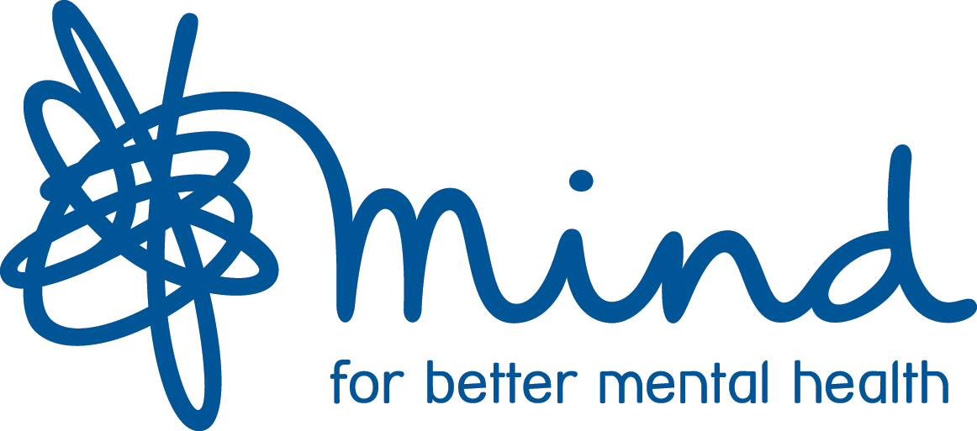

Mind BLMK

Equal Opportunities and Disability Monitoring

We aim to provide equal opportunities and fair treatment for everyone. We would like you to complete this form in order to help us understand who we are reaching and to better serve the community. All details will be treated as confidential and are held in accordance with the Data Protection Act 1998.

Name:
Age group: | Gender: |  | Sexual orientation: | Religion/Faith:
17 or under   18-29   30-39   40-49   50-59   60-69   70 and over   Prefer not to say  | Male   Female   The gender ticked above is different from the sex assigned to me  at birth   Prefer not to say  |  | Bisexual   Gay man   Lesbian   Heterosexual   Other   Please specify:  Prefer not to say  | No religion/faith   Christian (any  denomination)   Buddhist   Hindu   Sikh   Muslim   Jewish   Other   Please specify:  Prefer not to say 
Disability: |  | Ethnicity:
Are your day-to-day activities limited because of a health problem or disability which has lasted or  is expected to last for at least  12 months?  No   Yes, limited a lot   Yes, limited a little   Prefer not to say   If yes, please specify briefly: |  | White English / Welsh / Scottish /Northern Irish /British   White Irish   White Gypsy or Irish Traveller   *Any other white background   Mixed White and Black Caribbean   Mixed White and Black African   Mixed White and Asian   *Any other mixed background   Black or British African   Black or British Caribbean   *Any other black background   Asian or British Indian   Asian or British Pakistani   Asian or British Bangladeshi   Asian or British Chinese   *Any other Asian background   *Please specify:  Prefer not to say 

Thank you for completing this form

